Project Design Phase-II

Data Flow Diagram & User Stories

Date: 14 june 2025

Team ID: LTVIP2025TMID32074

Project Name: Sustainable Smart City Assistant

Maximum Marks: 4 Marks

# Data Flow Diagram (DFD)

A Data Flow Diagram (DFD) illustrates the flow of data in the Sustainable Smart City Assistant system. It helps in visualizing how user input is processed by the API, passed to the AI model, and how responses are returned to the frontend.

Context-Level (Level-0) DFD:  
  
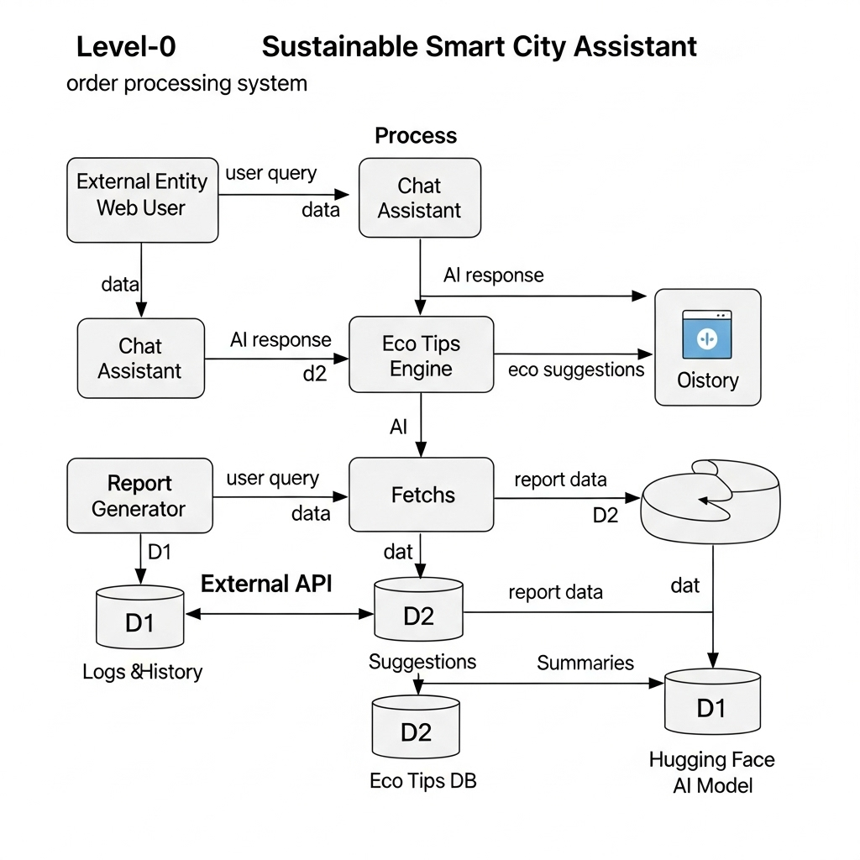

External Entities:  
- Web User  
- Hugging Face API

Processes:  
- Streamlit Frontend (UI Input/Output)  
- FastAPI Backend (Request Handling & Routing)  
- AI Model Inference (Query → Response)

Data Stores:  
- Internal logs (e.g., chat history, reports)  
- Environmental tips database (if used)  
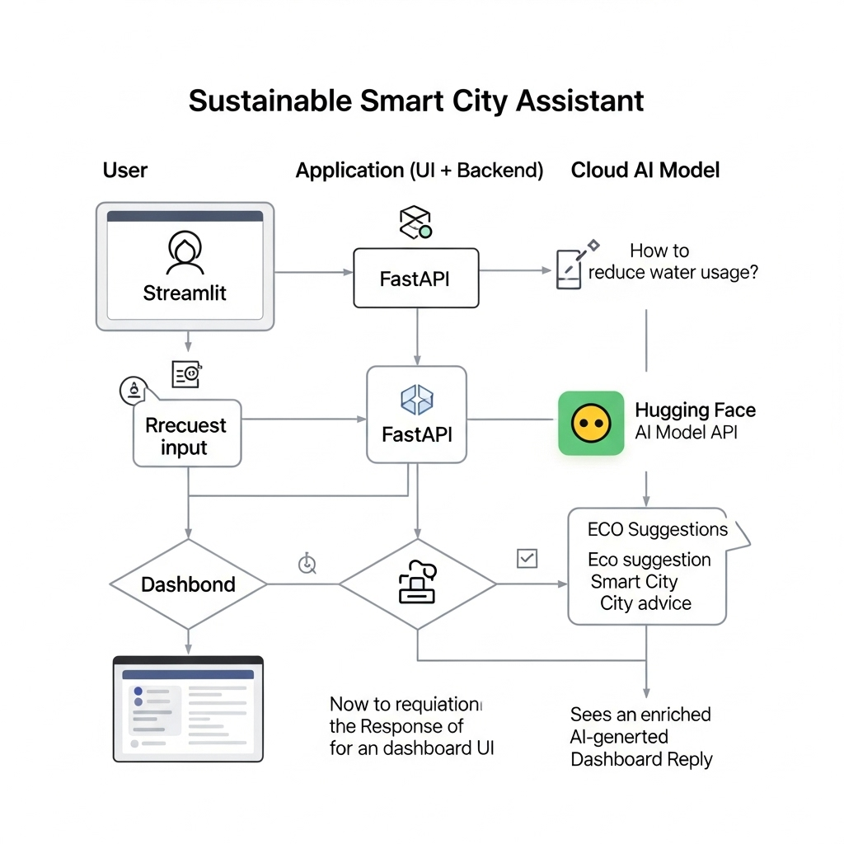

# User Stories

|  |  |  |  |  |  |
| --- | --- | --- | --- | --- | --- |
| User Type | Functional Requirement (Epic) | User Story Number | User Story / Task | Acceptance Criteria | Priority / Release |
| Web User | Registration | USN-1 | Register using email and password | Access dashboard after registering | High / Sprint-1 |
| Web User | Email Confirmation | USN-2 | Receive confirmation email | Confirm email and proceed | High / Sprint-1 |
| Web User | Login | USN-3 | Log in with email and password | Access dashboard on correct credentials | High / Sprint-1 |
| Web User | Chat Assistant | USN-4 | Ask sustainability-related questions via chat | Receive relevant AI answers | High / Sprint-2 |
| Web User | Eco Tips | USN-5 | View eco-friendly suggestions | Receive helpful, categorized tips | Medium / Sprint-2 |
| Web User | Report Generator | USN-6 | Generate query-based reports | Download/view clean summary report | Medium / Sprint-3 |
| Web User | Streamlit Interface | USN-7 | Interact with Streamlit dashboard | Modules accessible via UI | High / Sprint-3 |
| Developer | Backend API | USN-8 | Create API routes | Routes return valid responses | High / Sprint-1 |
| Developer | HF Integration | USN-9 | Integrate Hugging Face API | Model gives formatted responses | High / Sprint-1 |
| Developer | Testing & Debugging | USN-10 | Test and debug full system | No errors during interaction | High / Sprint-4 |
| Administrator | Usage Monitoring | USN-11 | Monitor assistant usage | View usage metrics | Low / Sprint-4 |
| Administrator | User Management | USN-12 | Manage registered users | Deactivate or delete users | Medium / Sprint-4 |